Issue 1: (Firefox only)

The close button should be displayed while hovering the mouse pointer. Failed in Firefox. The close button not displayed while hovering over. Passed in Chrome, IE, and Edge. Screenshot attached

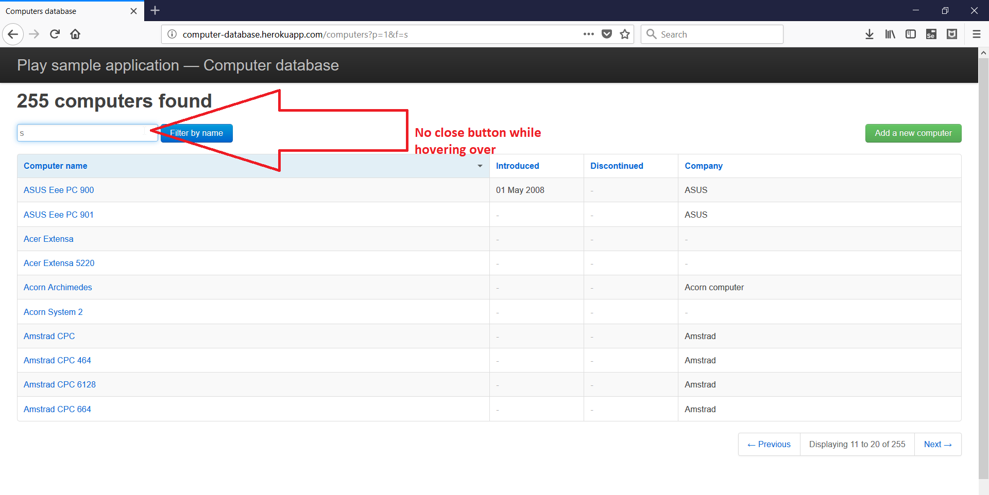

Issue 2:

The total count is found reducing when navigating through pages under a search. Total count not displayed correctly always

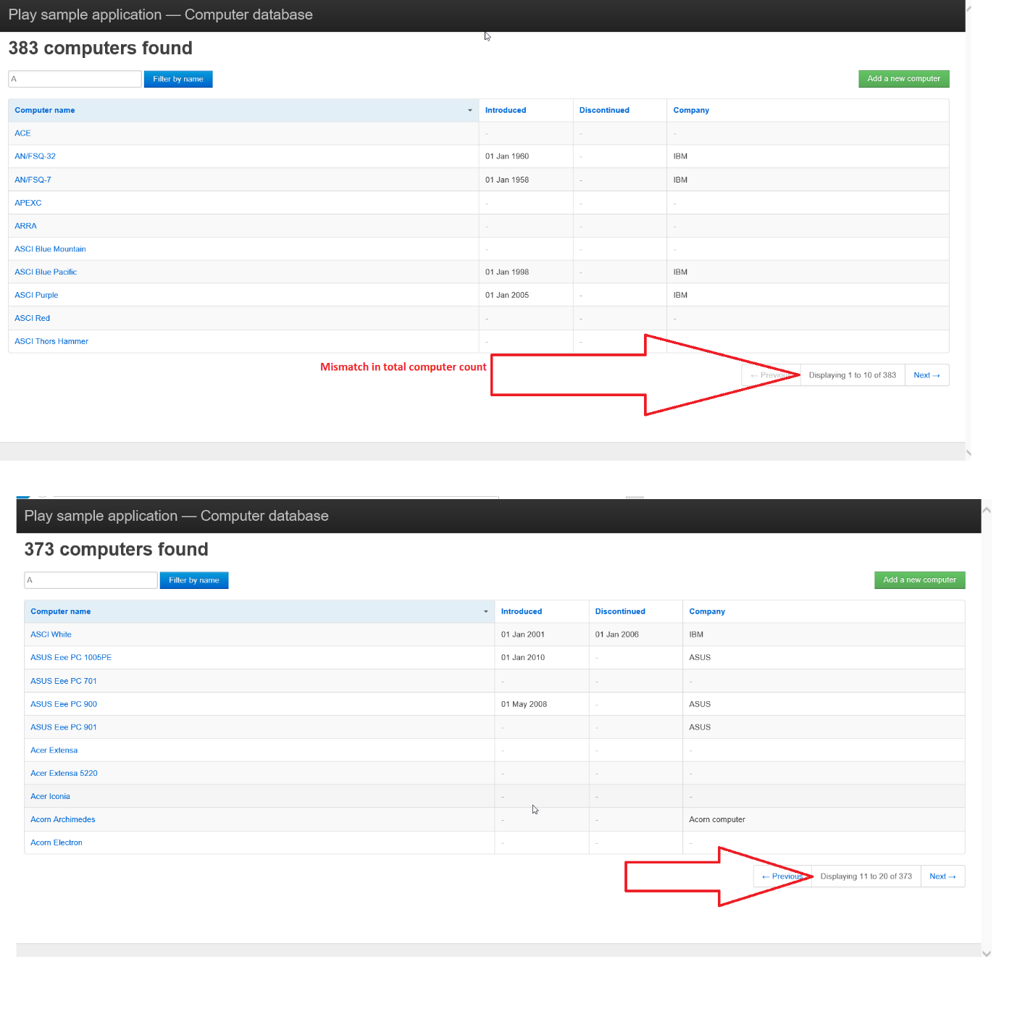

Issue 3:

The application is not intact. Incorrect value is displayed in Navigation panel

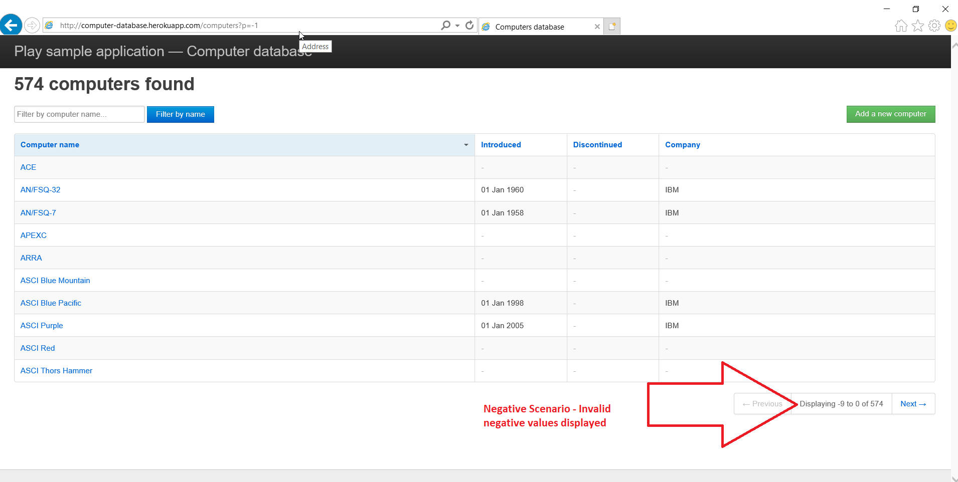

Issue 4: The page is not responsive in Main computer page. UI Components are hidden and sometimes overlapped

A) By providing small value for width in device compatibility mode

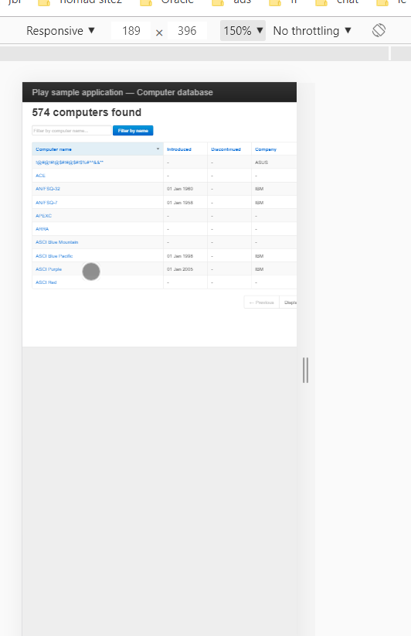

B) By reducing the window width

